**OTC ELECTRICAL** 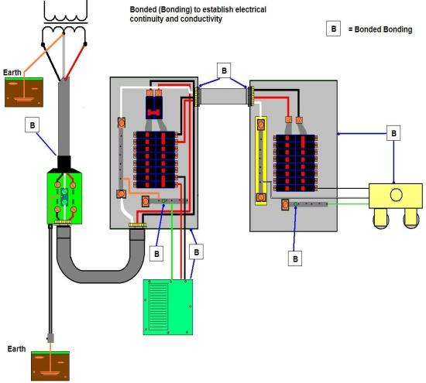

**APPRENTICESHIP PROGRAM**

P.O. Box 1279

# Malvern, AR 72104

(501) 617-0683

(501) 262-5551 FAX

July 5, 2024

Dear Employer:

The new affidavit leaves a lot to be desired. I hope this helps.

The top section needs to be filled out in its entirety.

First name, Last name, Middle name or initial

Address needs to be the complete address including apartment number, ETC

The email needs to be the most current email. Please make sure that is correct, if there’s a dot in it, put the dot. If there’s an underline put an underline, a dash put the dash. Please put their most current phone number as well.

The date of verification of employment is probably the one that gets messed up the most.

I encourage you to put it from the date they start working for you, to a specific date that you are verifying. If you’re doing it for the time period that ends January 1, 2079, then put that date, **please do not put “present”. It will get kicked back every time.**

If the apprentice works for you multiple times you have to make an affidavit **for each time period**.

The work under supervisor is, basically the same. It can be you (use your master license) or it can be whatever journeyman or master they’re working under. Again, the dates need to be from the time that they worked under them and **do not use “present”.**

Verified job duties “Be specific “for example, pulling wire, running conduit, mount out boxes, making up devices’ clean up the job site, or organizing the work truck**. DO NOT PUT “perform maintenance anywhere”**. If they see maintenance, they are going to kick it out.

Down at the bottom of the hours work, you put the hours in any way you want to split them up, residential, commercial, and industrial construction. BUT if you put anything under Sign specialist or industrial maintenance, it will not be counted, if you look to the right of the hours for each year employment, industrial maintenance, and sign specialist do not qualify work hours for journeyman or master license. Also disregard “**MAXIMUM OF 2000 HOURS FOR EACH YEAR OF EMPLOYMENT ALLOWED**”. If a person works 4000 hours a year it counts. The question was asked and that rule is now where to be found in the laws or regs.

Please sign and have it notarized. They can be turned in by mail, scanned or brought to school. I typically like them from January to the end of June and first July to end of December but so long as you do them systematically at least quarterly. It’s all good.

I hope this helps. Thank you.

If you have any questions, please contact Jim Burbridge by phone at (501) 538-3637 or by email at [otceap@gmail.com](mailto:otceap@gmail.com) .

Sincerely,

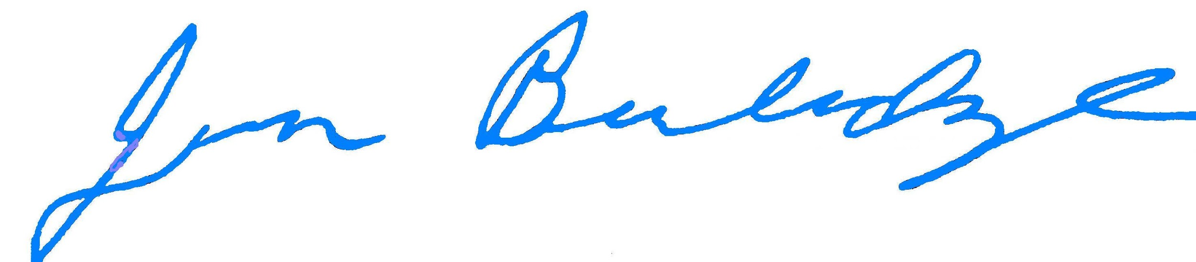

Jim Burbridge, Chairman

OTC Apprenticeship Program